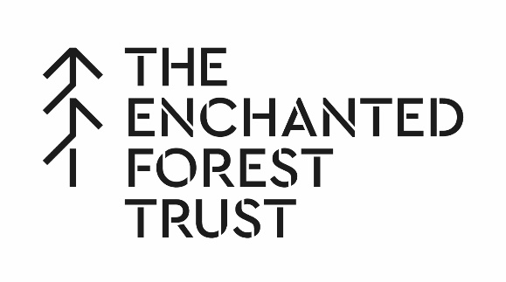
Community Fund Application Form
(please print your details clearly)

Section 1: Contact Details

Your name
Name of organisation
Website URL
Email address
Telephone | Daytime: | Alternative:
Correspondence address
(inc postcode)
Organisation address (if different from above)
Section 2: About your organisation

Are you a registered charity? If yes, please provide charity number.
What are the main activities of your organisation/what service do you provide?

Section 2: Continued

Please describe the project you are looking for the EFCT to fund.
How will this project benefit the community?
How much are you applying to EFCT for? | How much does your project cost? |  | When will the project take place?
£ | £
Will you be contributing any other funds/ undertaking local fund-raising to help meet the costs? If so, please provide details.
Declaration: By submitting this application to the EFCT you certify that the information herein contained is correct and that, if you are awarded a grant, you will use it only for the purposes described above. You understand that decisions made by the Trustees of the EFCT are final.
Signed: |  | Date:
Completed applications should be returned, no later than 28th February 2020, to Allie Walker, either by email: community@enchantedforest.org.uk or c/o Walton Kilgour, 30 Bonnethill Road, Pitlochry, PH16 5BS

